CSC 122 001 Computer Science II  
Julius Ranoa

**Quiz 6. Program 17-9 Modification.**

Alter the source code such that the driver program uses the same processes with doubles, characters, and strings (std).

**Implementation.**

I’ve created three functions that are practically copies of each other, only differing in the data type of the list members and given test data.

1. *doubleList*. A list of doubles. Test data: A sequence from n = 0 to n = 10 with an = 9.99n.
2. *charList*. A list of characters. Test data: All uppercase letters from ‘A’ to ‘Z’
3. *stringList*. A list of string objects. Test data: Each word from this sentence: “The quick brown fox jumps over the lazy dog.”; is added as a list member. *(The string stream library is used to automate this process.)*

**Screenshot of Runtime:**

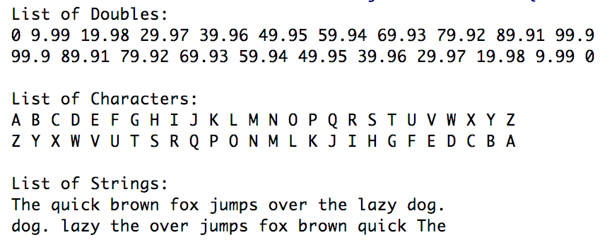

**Files Included: (1) main.cpp**

**main.cpp**

*// This program demonstrates the STL list container.*#include **<iostream>**#include **<list>** *// Include the list header*#include **<string>**#include **<sstream>  
using namespace** std;  
  
**void** doubleList();  
**void** charList();  
**void** stringList();  
  
**int** main()  
{  
 doubleList();  
 charList();  
 stringList();  
 **return** 0;  
}  
  
**void** doubleList() {  
 list<**double**> myList;  
 list<**double**>::iterator iter;  
  
 *// Add values to the list* **for** (**double** x = 0; x < 100; x += 9.99)  
 myList.push_back(x);  
  
 cout << **"List of Doubles: \n"**;  
 *// Display the values* **for** (iter = myList.begin(); iter != myList.end(); iter++)  
 cout << *iter << **" "**;  
 cout << endl;  
  
 *// Now reverse the order of the elements* myList.reverse();  
  
 *// Display the values again* **for** (iter = myList.begin(); iter != myList.end(); iter++)  
 cout << *iter << **" "**;  
 cout << **"\n\n"**;  
}  
  
**void** charList() {  
 list<**char**> myList;  
 list<**char**>::iterator iter;  
  
 *// Add values to the list* **for** (**int** x = (**int**)(**'A'**); x <= (**int**)(**'Z'**); x += 1)  
 myList.push_back((**char**)(x));  
  
 cout << **"List of Characters: \n"**;  
 *// Display the values* **for** (iter = myList.begin(); iter != myList.end(); iter++)  
 cout << *iter << **" "**;  
 cout << endl;  
  
 *// Now reverse the order of the elements* myList.reverse();  
  
 *// Display the values again* **for** (iter = myList.begin(); iter != myList.end(); iter++)  
 cout << *iter << **" "**;  
 cout << **"\n\n"**;  
}  
  
**void** stringList() {  
 list<string> myList;  
 list<string>::iterator iter;  
  
 string test = **"The quick brown fox jumps over the lazy dog."**;  
 istringstream iss(test);  
  
 string temp;  
 **while**(iss >> temp) {  
 myList.push_back(temp);  
 };  
  
 cout << **"List of Strings: \n"**;  
 *// Display the values* **for** (iter = myList.begin(); iter != myList.end(); iter++)  
 cout << *iter << **" "**;  
 cout << endl;  
  
 *// Now reverse the order of the elements* myList.reverse();  
  
 *// Display the values again* **for** (iter = myList.begin(); iter != myList.end(); iter++)  
 cout << *iter << **" "**;  
 cout << **"\n\n"**;  
}